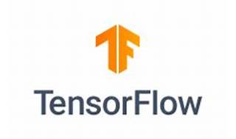

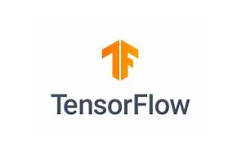

Explore

**TensorFlow Quantum (TFQ)** is a **Python framework for quantum machine learning** that allows researchers to leverage Google’s quantum computing frameworks within TensorFlow. [It focuses on quantum data and building hybrid quantum-classical models, integrating quantum algorithms and logic designed in Cirq1](https://www.tensorflow.org/quantum)[2](https://www.tensorflow.org/quantum/overview)[3](https://pypi.org/project/tensorflow-quantum/).

Here are **five reference links** where you can learn more about TensorFlow Quantum:

1. [**TensorFlow Quantum Overview**](https://www.tensorflow.org/quantum): Start with this official overview to understand the basics and explore the library.
2. [**Quantum Convolutional Neural Network Tutorial**](https://www.tensorflow.org/quantum/tutorials/qcnn): Learn how to implement a simplified Quantum Convolutional Neural Network (QCNN) using TFQ.
3. [**Hello, many worlds**](https://www.tensorflow.org/quantum/tutorials/hello_many_worlds): Discover how classical neural networks can learn to correct qubit calibration errors with Cirq and TensorFlow Quantum.
4. [**Research Tools**](https://www.tensorflow.org/quantum/tutorials/research_tools): Dive into incorporating TensorBoard into your quantum computing research.
5. [**TensorFlow Quantum White Paper**](https://arxiv.org/abs/2003.02989): For an in-depth understanding, explore the white paper that covers theory, applications, and advanced quantum learning tasks[4](https://arxiv.org/abs/2003.02989).

Happy learning! 🚀🔬🌟